DBMS

Ex–6 Join Commands

Name:- K. DUSHYANT REDDY Reg No.:- RA1911033010029

Branch:- CSE-SE

AIM:

To implement commands like inner, outer, cross, left, right and full join.

COMMANDS:

1. CROSS JOIN – Used to join the cartesian product of the rows in the table.

Syntax-

SELECT <column name> FROM <table-name1> CROSS JOIN <table-name2>;

CODE-

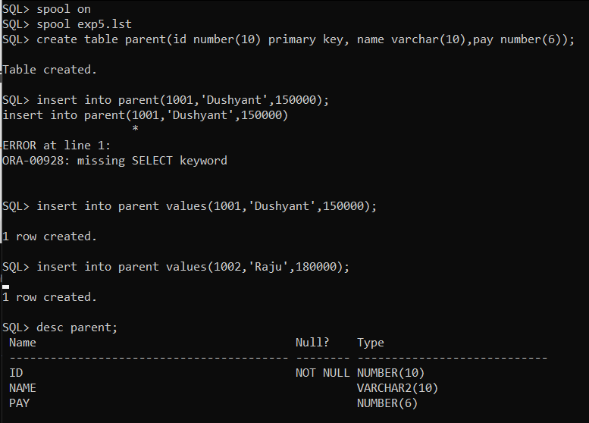

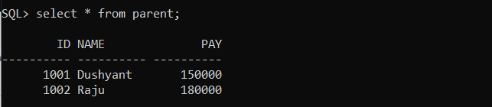

1. INNER JOIN – Used to join on basis of matched data as per the equality condition.

Syntax-

SELECT <column name> FROM <table-name1> INNER JOIN <table-name2> WHERE <table-name1>.<column-name> = <table-name2>.<column-name>;

CODE-

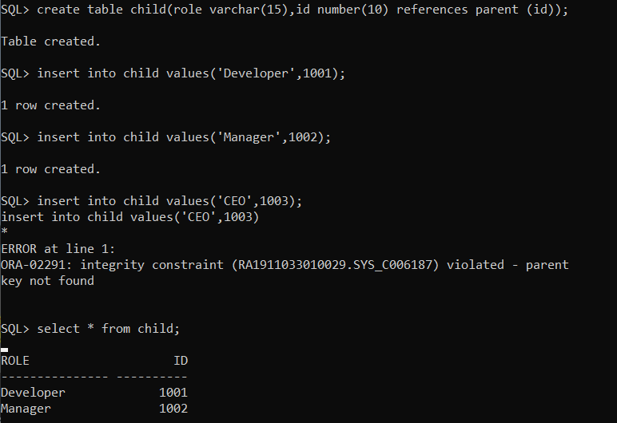

1. NATURAL JOIN – Used to join on basis of column having same value and datatype in both the tables.

Syntax-

SELECT <column name> FROM <table-name1> NATURAL JOIN <table-name2>;

CODE-

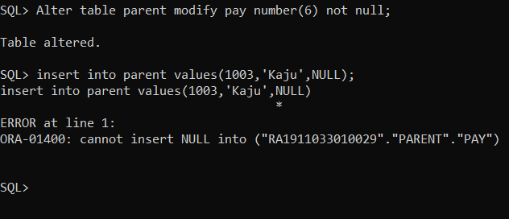

1. LEFT OUTER JOIN – Used to return a table with matched data of two tables then remaining of left table and null for right.

Syntax-

SELECT <column name> FROM <table-name1> LEFT OUTER JOIN <table-name2>;

CODE-

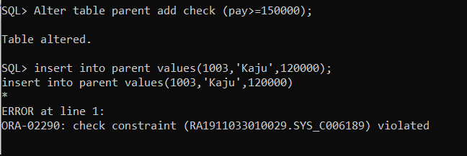

1. RIGHT OUTER JOIN – Used to return a table with matched data of two tables then remaining of right table and null for left.

Syntax-

SELECT <column name> FROM <table-name1> RIGHT OUTER JOIN <table-name2>;

CODE-

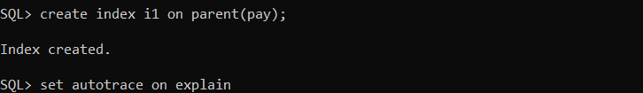 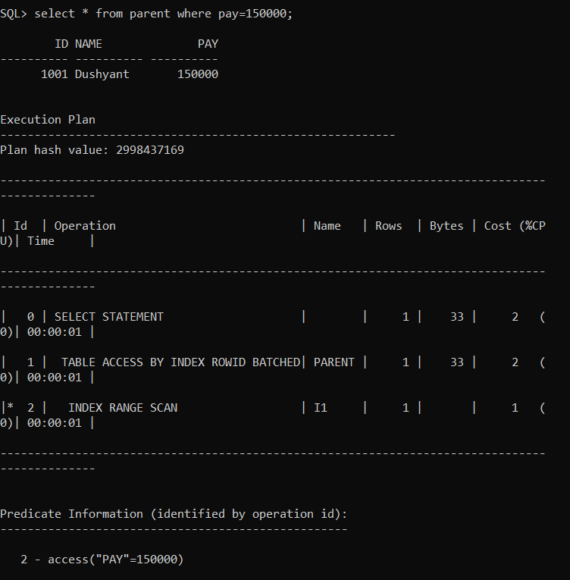

1. FULL OUTER JOIN – Used to return a table with matched data of two columns of all remaining data as well.

Syntax-

SELECT <column name> FROM <table-name1> FULL OUTER JOIN <table-name2>;

CODE-

 

RESULT:

Thus, the join commands have been executed successfully.